Token Board Tokens Reward Cards
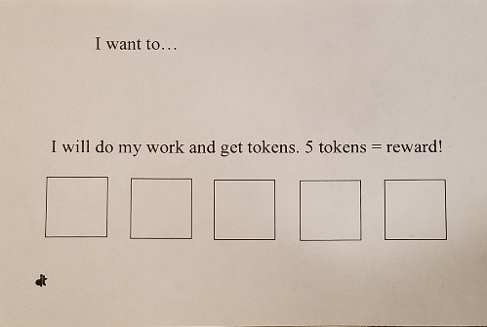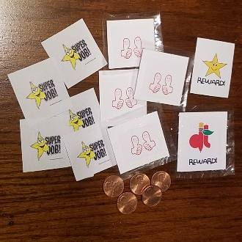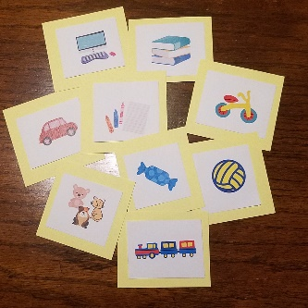

I like to do my school-work. Today, I will do my school-work. I can choose the reward picture to put on my token board when I start my work. I will get tokens to put on my token board. When I get a token, I am happy. I will do more work and get more tokens. When I get 5 tokens, I will get a reward. A reward is something that I like. A picture of a reward is on my token board. After I get my reward, I can do more work, earn more tokens and get another reward!
I like doing my school-work. I like getting tokens.
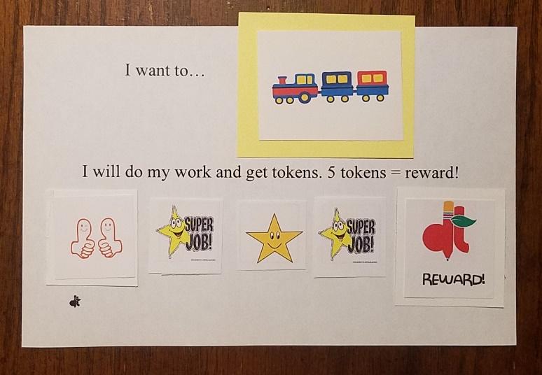
I really like getting a reward!

