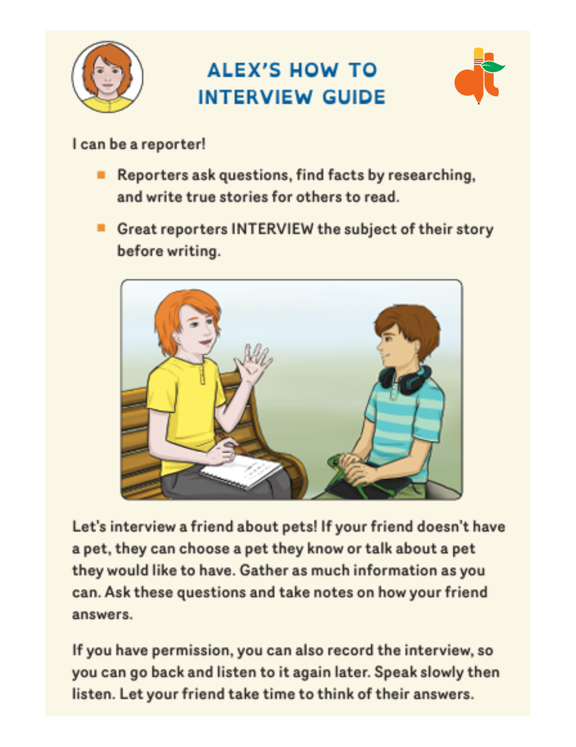
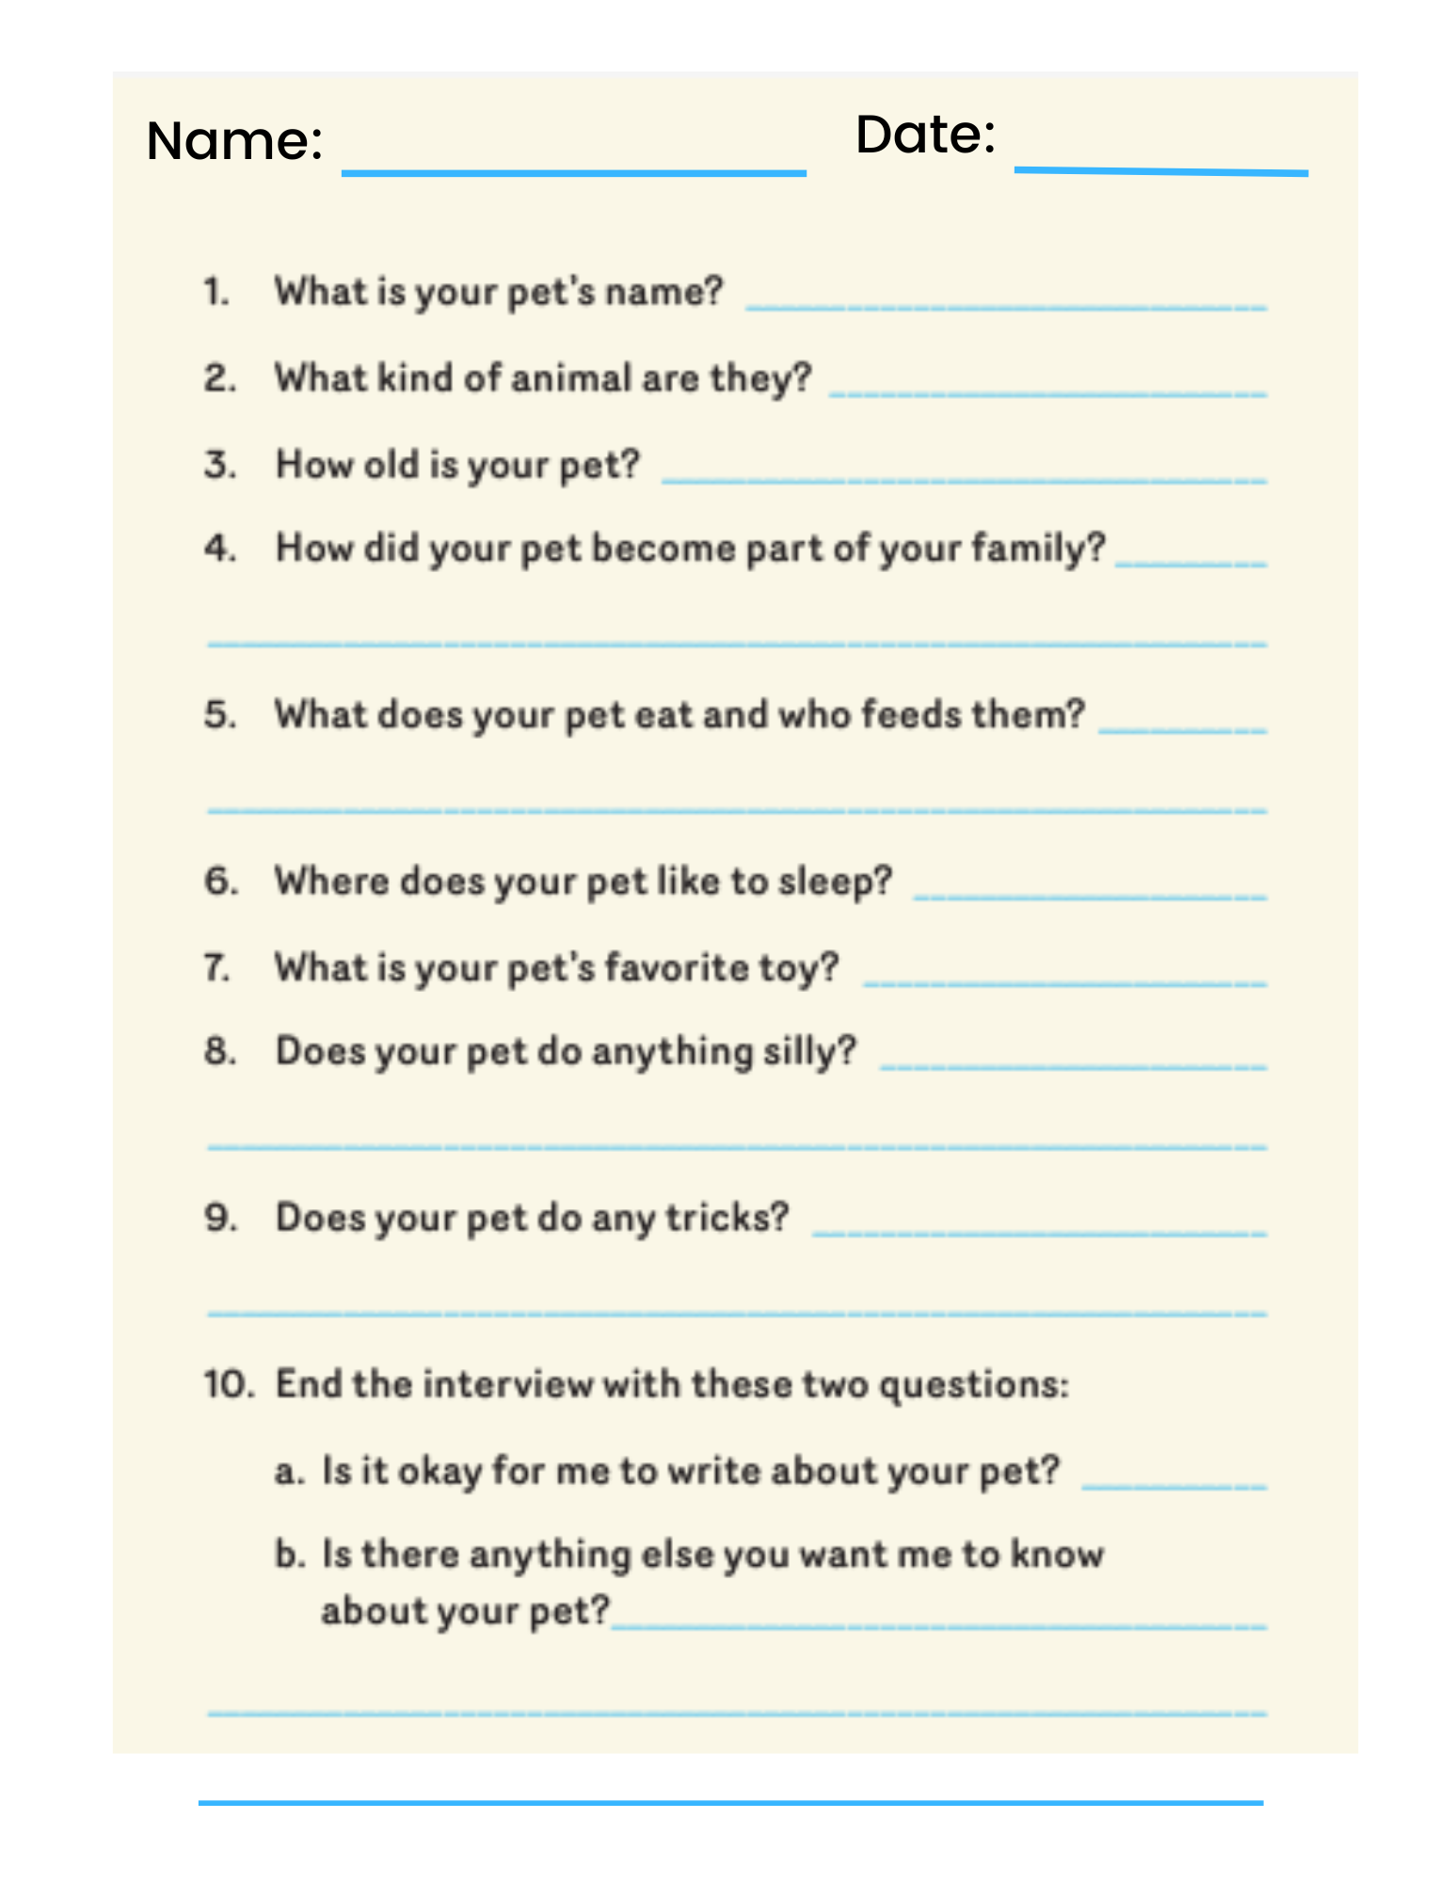
Name ___________________________ Date ________________
- What is your pet’s name? _____________________________
- What kind of animal is it? ______________________________
- How old is your pet? _________________________________
- How did your pet become part of your family? _____________
__________________________________________________
- What does your pet eat, and who feeds it? ________________
__________________________________________________
- Where does your pet like to sleep? ______________________
- What is your pet’s favorite toy? _________________________
- Does your pet do anything silly? ________________________
__________________________________________________
- Does your pet do any tricks? ___________________________
__________________________________________________
- End the interview with these two questions:
- Is it okay for me to write about your pet? _________________
- Is there anything else you want me to know about your pet?
________________________________________________________________________________________________________

