Regulation Support Cards: nancyroop.com

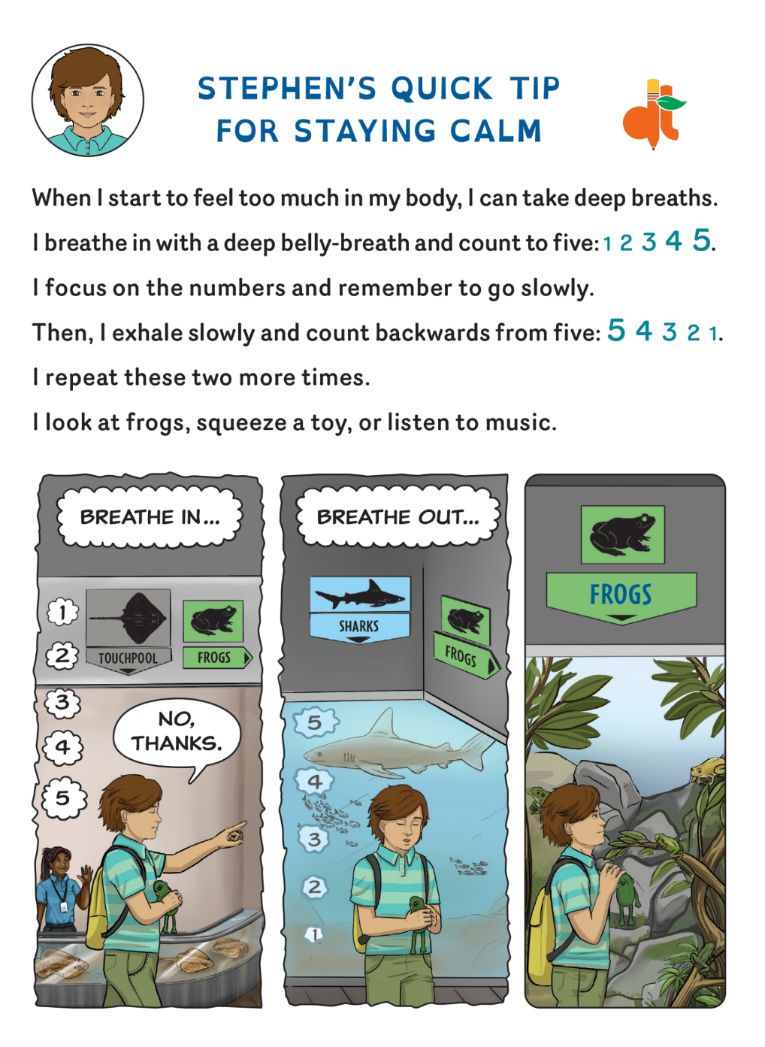
1.PRINT: paper--FOLD back-to-back. Cardstock--print on both sides with flip on short edge. 2. TRIM 1¼ inch from top. 4. LAMINATE.
